Adding New Assets to the LockPath Asset Tracker

This tutorial is to establish a consistent method for creation of Assets Records within the LockPath Keylight Platform, the IT-GRC solution deployed and utilized within the University of Chicago Biological Sciences Division (BSD).

This tutorial applies to all members of BSD who are responsible for contributing to the Assets Record by either manually entering Assets Records or assisting in parsing of Assets Records from a contributing system.
Note: This system aligns with NIST Cyber Security Framework ID.AM-1: Physical devices and systems within the organization are inventoried.

How to add a new Asset to LockPath Asset Tracker

- Go to https://itcompliance.bsd.uchicago.edu/
- Click Single Sign-On.
- Enter your CNet ID and password.
- After you log in, move your mouse pointer over the Keylight menu in the upper-right corner of the screen, to the left of the Search field.
- From the drop-down menu, under the Keylight Sm section, click Assets.
- In the left pane, click to expand the Device Asset Tracker group.
- Click Add New.
- You will be guided to the New Record page.
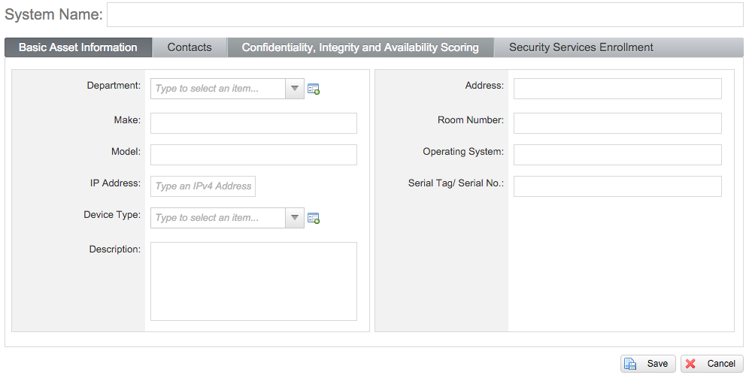

- Enter a System Name and move to the fields below.
- Enter the following under the Basic Asset Information tab:
  - Department
  - Make
  - Model
  - IP Address
  - Device Type
  - Description
  - Physical Address
  - Room Number
  - Operating System
  - Serial Tag / Serial No.
- Enter the following under the Contacts tab:
  - IT Custodian
  - System Owner
  - Department EA
- Enter the following under the Confidentiality, Integrity and Availability Scoring tab:
  - Data Availability Score
    - Data Availability Score Comment
  - Data Confidentiality Score
    - Data Confidentiality Score Comment
  - Data Integrity Score
    - Data Integrity Score Comment

Note: For more information on performing CIA scoring for a system, see Appendix B of the IT Asset Inventory and Categorization standard.

- Click Save.

Your device will be verified and added to the LockPath database. Thank you for your contribution.
Note: Regarding possible integration between a departmental asset management solution and LockPath; utilizing API, we are able to automate the import of requested fields using our BSD IT Asset Integration Engine, Ambassador. If you wouls like more information on this subject, please contact us via email at s.cri.security@bsd.uchicago.edu.

